Peoria Fire Department
April 2020 Responses & Times by Council District

This is the response and times data for April 2020. Responses include all apparatus that responded and do not represent incident counts alone. A Fire incident may require 7 or more apparatus. Administrative personnel and Investigator personnel are not included in this report. All times are at the 90th percentile.

This is the total overall responses citywide.
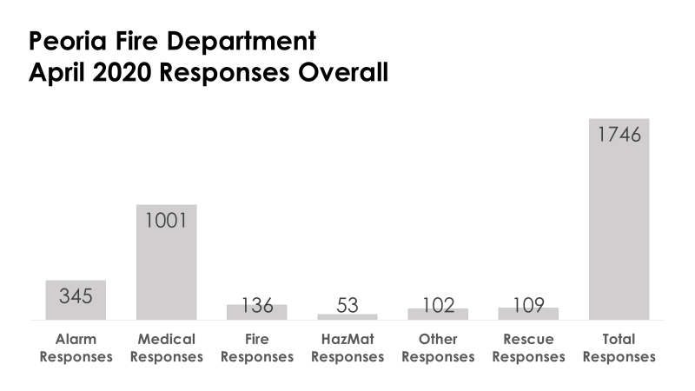
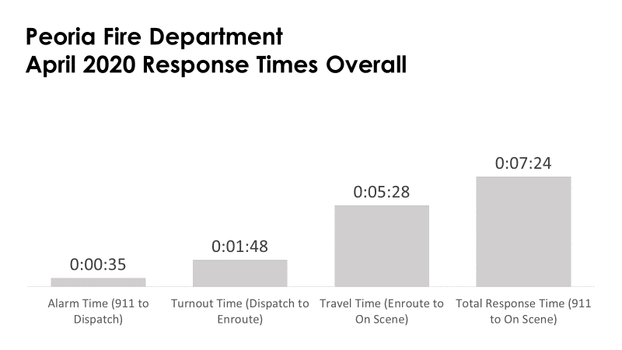
Travel Time Comparison
This chart compares all the Council Districts travel time compliance. NFPA 1710 states it should be 0:04:00.
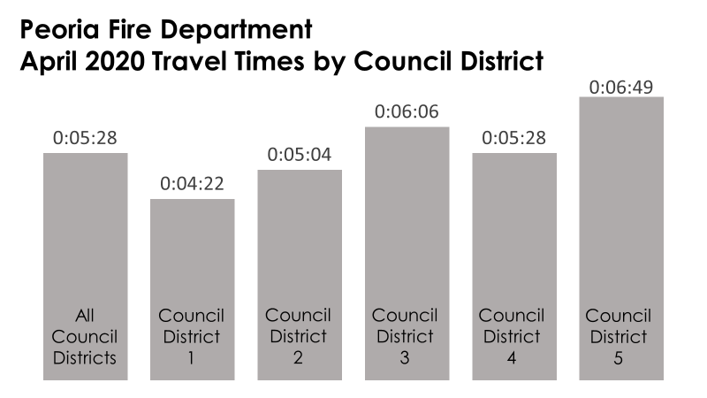

The following map allow visualization of the city according to council district.

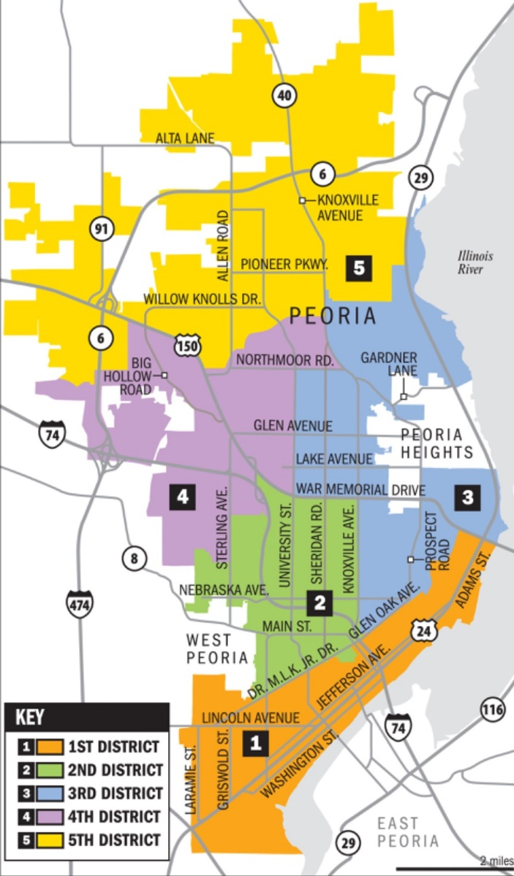

First District Data
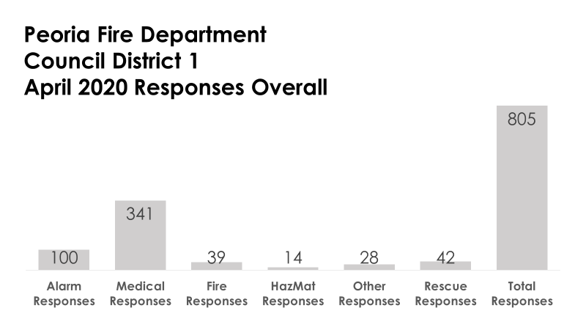
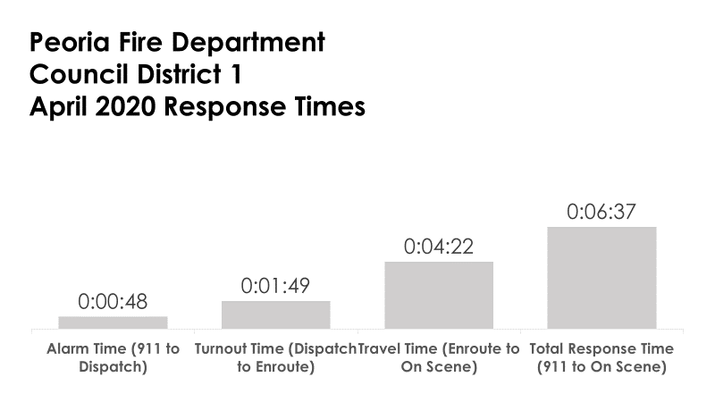
Second District Data
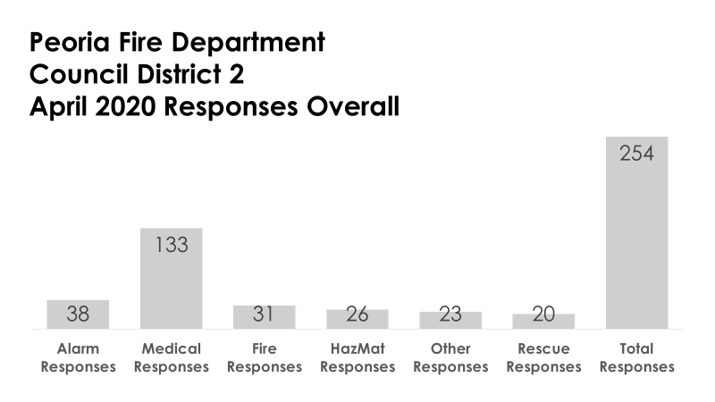
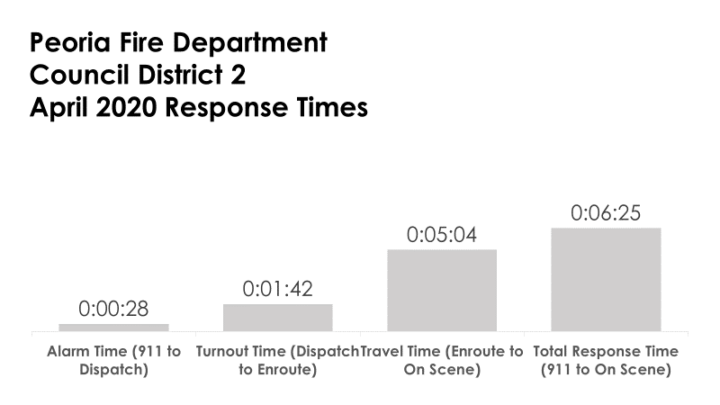

Third District Data
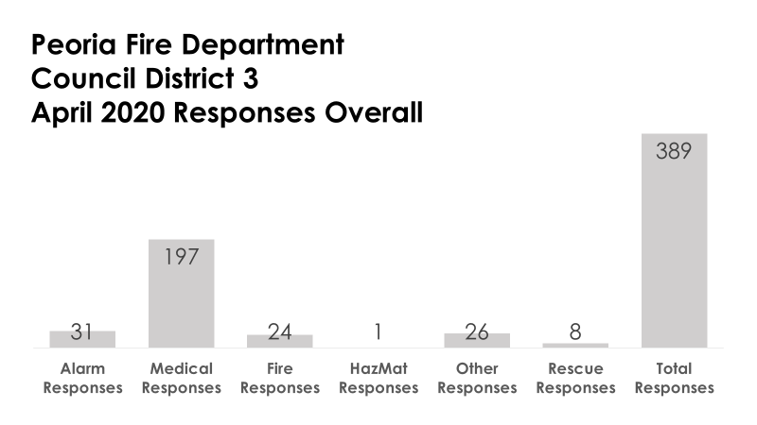
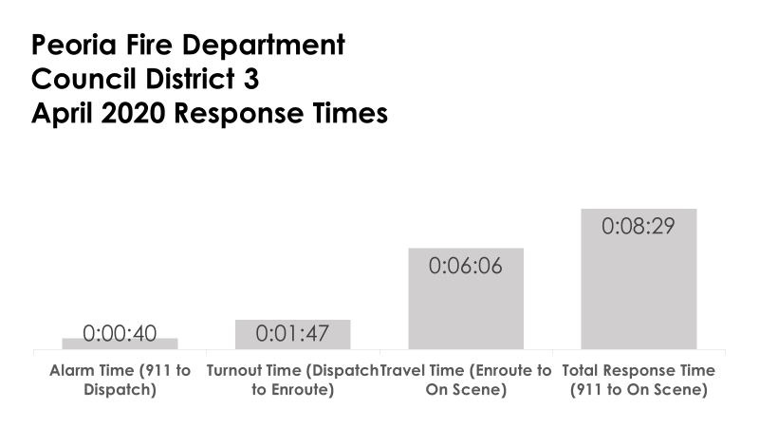

Fourth District Data
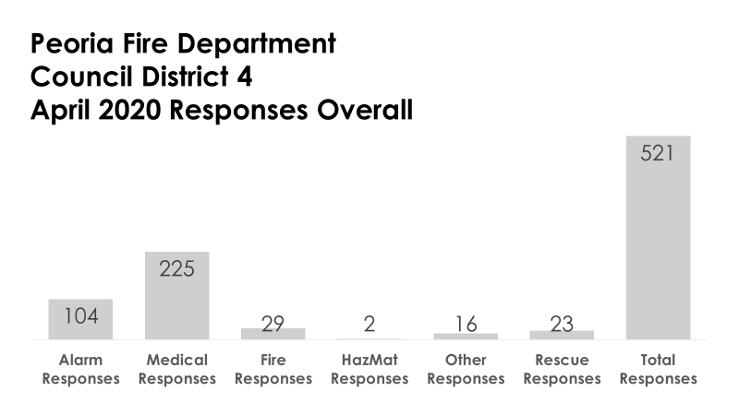
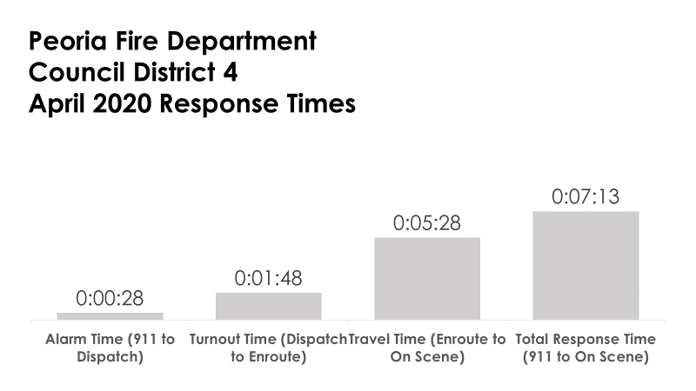

Fifth District Data
